
INFORMCANADA – 2012 CCIRC Bursaries 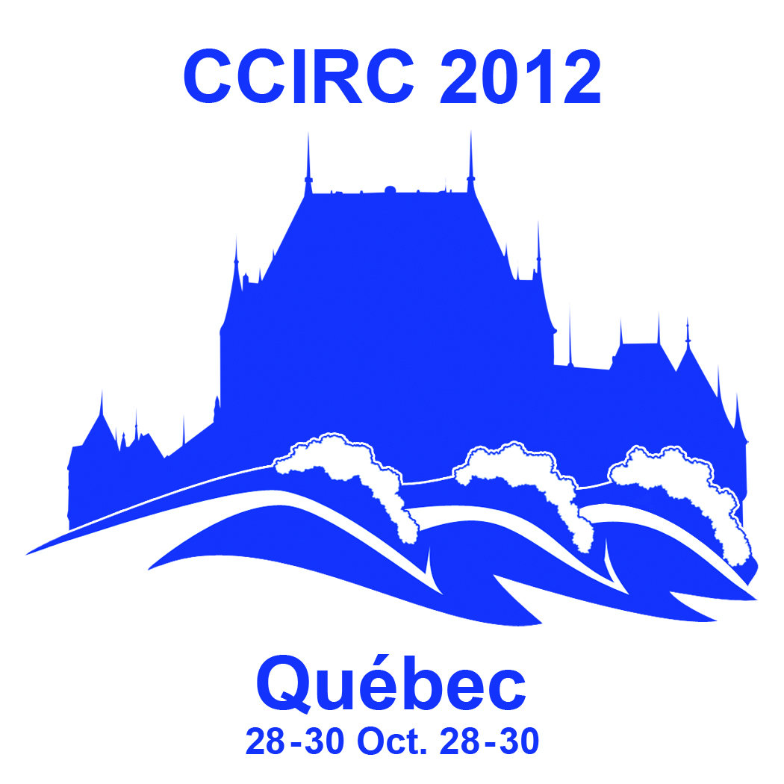

InformCanada is offering staff of member agencies the chance to receive a bursary to offset the cost of attending the Canadian Community Information & Referral conference (CCIRC) in Quebec City. The conference is being held Oct 28 to 30 2012.

Visit the InformCanada website for detailed information about the conference as well as links to hotel and tourist information.

Bursary recipients must be attending the full conference and cover any unmet or remaining costs themselves.

- Members located within Ontario or Quebec can apply to a maximum of $500.
- Members outside of Ontario or Quebec can apply to a maximum of $1,000.

To apply for a bursary please email a letter of support, your resume, and a short personal essay by 4pm Eastern Time, Friday August 31 to Jacky Roddy InformCanada at info@informcanada.ca. If you have any questions please call Jacky at 905-682-1900 ext 230 or email at info@informcanada.ca

Your submission must include the following:
- A letter of support from a colleague, Executive Director or Board Member that includes the following information:
  - Length of time in the job
  - Quality of applicants’ skill and challenges of applicants’ position
  - Applicants commitment to excellence
  - If the applicant has attended other I&R conferences

- A short (no more than 400 words) personal essay that answers the following question.
How would attending the 2012 conference attribute towards your ability to perform your job and assist your organization in the delivery of I&R services.

- Applicants must provide the following information
  - Name
  - Organization and InformCanada Membership number
  - Email
  - Phone
  - Dollar value of bursary requested.

